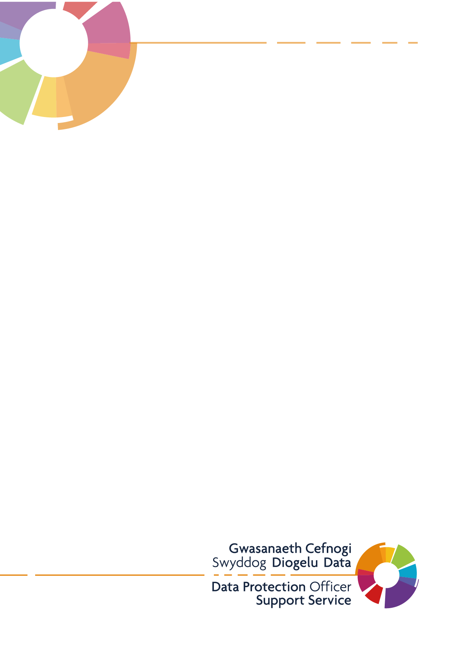
Publication Scheme
Template & Example

Introduction
This example publication scheme has been created to outline the types of information that the Practice is expected to publish. The example is based upon the ICO model publication scheme and is broken down into the classes of information required under the Freedom of Information Act 2000. It is recommended that this is laid out in its own section of your Practice’s website, with the below headings listed.
Your Rights to Information
The Freedom of Information Act (FOI) 2000 provides members of the public with the right access information held by public authorities.
Public authorities are required to routinely publish certain information to the public as part of its normal business activities. This is known as a publication scheme.
The Whitchurch Medical Centre Publication Scheme is designed to signpost individuals to information we proactively release as and when it becomes available. The aim of this is to explain what information the practice makes available to the public and where possible to provide an easy method of accessing it.
The Publication Scheme contains seven classes of information, as follows, and information falling into each of these classes is published on our practice website:
- Who we are and what we do
- What we spend and how we spend it
- What are our priorities and how we are doing
- How we make decisions
- Our policies and procedures
- Register of members’ interests
- Services we offer
All the information we proactively release is available free of charge on our website. Our publication scheme is a useful place to start if you’re looking for information about Whitchurch Medical Centre before making a Freedom of Information request.
Information that is not published under the FOI Publication Scheme can be requested in writing and the release of such information will be considered in accordance with the provisions of the FOI Act 2000.
To make a Freedom of Information request, please email contact the practice Practmail.w97294m@wales.nhs.uk or write to:
Whitchurch Medical Centre
Park Road
Whitchurch
Cardiff
CF14 7EZ
Who we are and what we do
Whitchurch Medical Centre has 10,500 patients in the North Cardiff Area. We are also a member of the West Cluster which is made up of 7 separate Practices. The practice was formed in 2020. Practice details and our opening times are published on our website, this information be accessed via www.whitchurchmedicalcentre.co.uk. The Practice employees the following people:
Partners: Dr. Niamh McConnell, Dr. Stuart Gray, Dr. Eleanor Davies, Dr. Sian Davies, Dr. Khurram Hashmi
Salaried GPs: Dr AiLean Ko, Dr. Sukhi Sharma, Dr. Holly Peters, Dr. Corinne Locke, Dr. Zubeida Gomez
Nurses: Sister Anne Stelfox, Sister Marilyn Griffiths, Sister Sian Mcshane, Julie Morgan, Julie Jones.
Further information regarding staff members can be found on our website www.whitchurchmedicalcentre.co.uk/team/

Other information is available on the practice notice boards and display tables in the waiting areas.

What we spend and how we spend it
Whitchurch Medical Centre receives money from NHS Wales according to its contract for national General Medical Services in exchange for services provided for patients. We do not wish to publish our annual salaries, but they are available on request.

What our priorities are and how we are doing
Currently our top priority is to provide a high standard of care to our local community. Whitchurch Medical Centre prides itself on being patient centred and offering a range of services to our patient population. As a practice, we offer a range of appointments to ensure everyone receives access to medical advice within a timely manner, be it by telephone or in a face-to-face consultation.

How we make decisions
Whitchurch Medical Centre has a monthly meeting which is made up of the senior partners and management. During this meeting changes may be discussed before a decision is made. Following this meeting, the information is shared to our Patient Participation Group to receive an opinion from patient body about the changes that could be made. Once the decision has been decided the change will be implemented across the practice and shared with the patient population.

Our Policies and Procedures
All policies and procedures are available for viewing, upon request in writing, please contact the Practice Manager, Practmail.w97294m@wales.nhs.uk.
If you have a complaint or concerns about the service you have received from the doctors or any of the staff working in this practice, please let us know. We operate a complaints procedure as part of the NHS system. Our complaints system meets national criteria. A copy of our practice complaints procedure is available here www.whitchurchmedicalcentre.co.uk/patient-info/complaints-compliments/ This will give you all the information and contact details needed to lodge a complaint.

The services we offer
In addition to routine and emergency services, we offer the following range of services under contract to the NHS:
- Maternity Medical Services
- Contraceptive Services
- Minor Surgery

Additional services may incur a private fee (including medical reports and travel vaccinations). We do not wish to publish this additional income, but they are available on request.

Additional - Disclosure Log

A disclosure log is used to publish any previous FOI requests and the response to these. For example, if someone asked you how often your practice gets a deep clean, the information you give to them can be published in this area. This will be helpful when people are looking to submit an FOI request to your practice, as then can check this log beforehand to see if the information they require has already been requested and published.

The method by which information published under this scheme will be made available
The practice will indicate clearly to the public what information is covered by this scheme and how it can be obtained.
Where it is within the capability of the practice, information will be provided on the website. Where it is impracticable to make information available on a website or when an individual does not wish to access the information by the website, the practice will assist to provide the information in the format it has been requested or offer an alternative method for it to be obtained.

Charges which may be made for information published under this scheme
The purpose of this scheme is to make the maximum amount of information readily available at minimum inconvenience and cost to the public. Charges made by the practice for routinely published material will be justified and transparent and kept to a minimum. Material which is published and accessed on a website will be provided free of charge.
Generally, only the following charges can be made:
- the costs directly incurred as a result of viewing information, photocopying, postage and packaging
- fees permitted by other legislation; and
- for information produced commercially, for example, a book, map or similar publication that you intend to sell and would not otherwise have produced.

